02

|  |  |
| --- | --- |
| MAkhuzwayo trading enterprise.  COMPANY PROFILE |  |

**Company Background**

**MAKHUZWAYO TRADING ENTERPRISE as** a newly formed privately owned company by an ambitious women namely Qwabe, Thenjiwe Nonhlanhla Nomvula and Qwabe Seddie Phumzile with intention to contribute towards building the nation at large.

**Vision**

**Our Vision** at MAKHUZWAYO TRADING ENTERPRISE is clear and simple we strive to do our projects with a view to forming longstanding partnership with our clients.

The Vision provides all staff with a clear focus on what is important to achieving business objectives as the go about completing their day to day roles.

We underpin this vision with a multi-layered leadership and management approach.

**Mission****Statement**

**Aims** to deliver superior professionally managed projects through excellent service delivery, the highest quality products provided. MAKHUZWAYO TRADING ENTERPRISE intends to deliver all projects on time within budget to ensure maximum financial returns and earn long term growth and stability, which will maximize stakeholder’s value. We aim to improve quality of our employees through impartial employment, equal opportunities and continue development.

**Design & Contribution**

In this role, MAKHUZWAYO TRADING ENTERPRISE takes full responsibility and ownership project delivery. We document the initial client brief, engage the consulting team, complete pre-construction authority approvals, then drive the program and delivery the end project through the construction phase.

**Objec*tives***

* Deliver on time and on budget.
* Provide the highest level of quality and finish
* Maintain the safety of our workforce
* Ensure client satisfaction and develop the opportunity for future business
* To create job opportunities for the unemployment youth of Kwamashu
* To deliver high quality service at all times
* To empower people with needed experience and skills
* To train and develop our staff to increase the level of productivity and maintain high quality service to our clients
* To be capable of meeting the ever-increasing demands of our clients.

**Services Offered**

* PLUMBING
* SEWER AND DRAINAGE
* MANHOLE
* FOAMWORK&STEELWORK
* SUPPLY AND DELIVERY



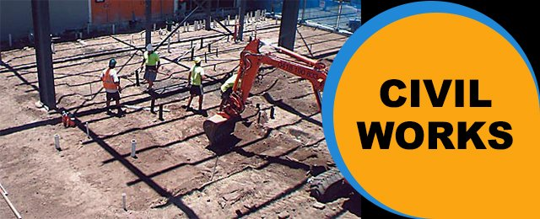

**SUPPLIER OF: CIVIL** CONSTRUCTION WORKS

-PAVING INSTALLATION

-V DRAINS INSTALLATION

-TAR LAYING

-RE-GRAVELLING

-SIDE WALKS CONSTRUCTION

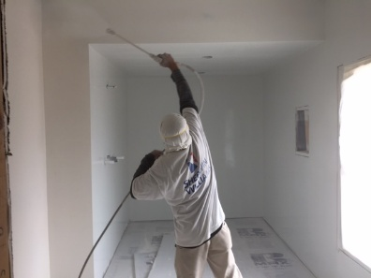

**PAINTING**

**-** ROOF PAINTING

- INTERIOR AND EXTERIOR

- WATER PROOFING

- INDUSTRIAL COASTINGS

- INFRASTRUCTURE PAINTING

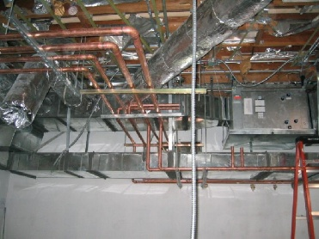

**SUPPLIER OF:**  **PLUMBING WORKS**

- SEWER

- DRAINAGE

- DOING MANHOLE



**SUPPLIER OF:** GENERAL BUILDING WORKS

-SITE PREPARATION

-FOUNDATION LAYING

-INSTALLING STEEL SHEET PILE WALLS

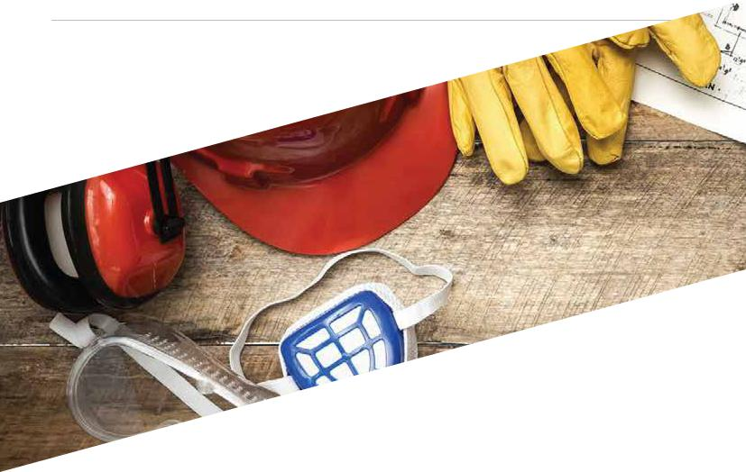**Health & Safety**

***MAKHUZWAYO TRADING ENTERPRISE health and safety*** commitment goes far beyond regulatory compliance and goodbusiness practice; it’s an integral element of our core values. We subscribe to the belief that accidents are prevention has much value as quality, morale and production, costs etc. MAKHUZWAYO TRADING ENTERPRISE dominant safety philosophy continues to encourage employees to protect and support each other within the work environment.

***As such, MAKHUZWAYO TRADING ENTERPRISE:***

* Promotes a culture of health and safety
* Complies with regulatory standards
* Continually enforces health and safety measures
* Promotes employee and employer participation in health and safety
* Regulate employer and employee responsibilities in identifying and
* Entrench the right to refuse to work in hazardous condition measures controlling unsafe conditions and most importantly, unsafe work practices



**Values**

Our values provide the standard of behavior by which MAKHUZWAYO TRADING ENTERPRISE conduct business. These values represent how we treat one another, deal with our customers, stakeholders and how we keep ourselves accountable as a team:



**Safety**

* The safety our employees, stakeholders and the public at large is our concern
* Ensuring that all safety aspects of our work is in place to execute projects successfully

S



**Reliability**

* Commit to clients realistically and follow up thereby enforcing consist-ent excellence.
* Be quick and responsive in business dealings within and outside the organization.

R



**Accountability**

* Open and transparent communication with high accountability levels
* Take swift and efficient steps to correct errors or defects and rejecting inconsistent behavior

A



**Our References**

**PLUMBING WORK**

**ON THE: 30/08/2016**

**MAGUBANE PLANT CONSTRACTORS**

ADDRESS: 15 SCOTT ROAD, PINETOWN, DURBAN, KWAZULU NATAL, 3600

**CONTACT NUMBERS: 0861227637/0844443365**

**PLUMBING WORK**

**ON THE: 29/05/2017**

**ADDRESS: NTUZUMA SAPS**

PO NTUZUMA

4360

Contact number: 0315098604

**PLUMBING WORK**

**ON THE: 05/01/2018**

**ADDRESS:** AUKFORD PRIMARY SCHOOL

PO VERULAM

4132

**CONTACT NUMBER**: 0724754606

_____________________________________________________________________________________

**PLUMBING WORK**

**ON THE: 07/01/2018**

**ADDRESS:** MOTHEO CONSTRUCTION

3 GREAT HEAD

PINETOWN

3600

**CONTACT NUMBER:** 0317014647

**Accounting Officers**

We use services of an external accountant to provide our business with accounting/ tax services.

**Name** : Sandile Eric Myeza

**Postal Address** : P1402 Phambili Road

Umlazi

2031

**Profession** : The South African Institute of Business Accounting

Diploma in Accounting

**Practice No.** : SAIBR371

**MAKHUZWAYO TRADING ENTERPRISE Cc**

##### **Registration No.:** **2006/180389/23**

**BUILDING – CIVIL – ROAD MAINTENANCE –– PLUMBING**

Company Profile

CONTACT US

Cell: 0727331843/ Address: C575 Ifafa Road, Kwamashu Township, Durban 4060

Email:Thenjiqwabe@Gmail.Com





BUSINESS PROFILE